Name of Student:
Name of the tutor:
Name of the Course:
Date:
The Formal Analysis and Critic of Caravaggio’s Painting, The calling of St Mathew Assignment
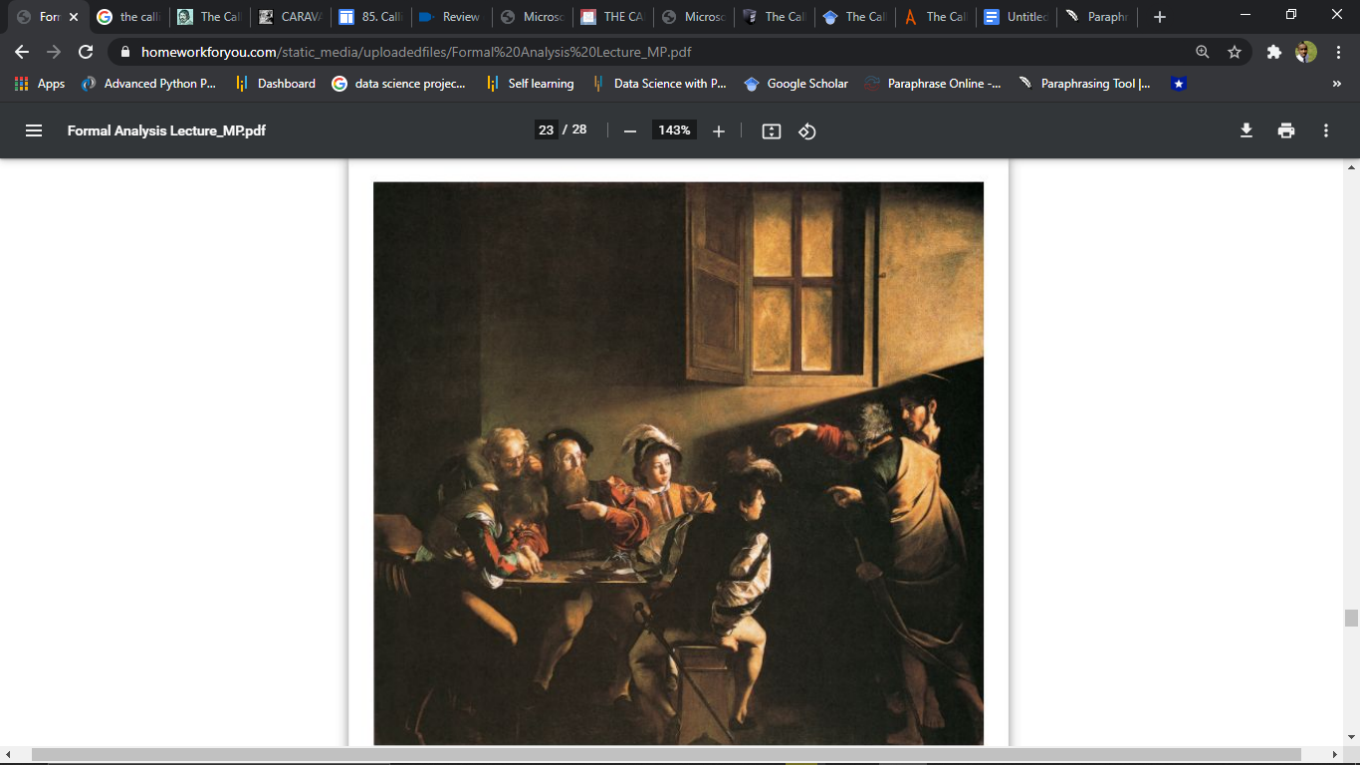
The calling of St Mathew (Majestic work, oil on canvas, 322 x 340 cm.) is a famous and cherished masterpiece painting done by Caravaggio, one of the most respected and famous artists of the Seventeenth Century. The painting was painted between the years 1599 to 1600. The painting shows the scene when Jesus Christ inspires a tax collector named Mathew to follow him and encourages him to become one of his disciples. The painting was commissioned as part of Cardinal Matthew Contarelli's will, which included funds and specific instructions for the decor of a cathedral inspired by Matthew's life. The painting was painted for the Contarelli Chapel in the cathedral in Rome, where it remains on display currently. The paintings of Caravaggio revealed a new religious strength and philosophy (Xu 1). He used dark colors to create his shapes, instead of the delicate tints used by earlier painters, to create a more emotional appeal. Caravaggio’s religious settings humanize and make commitment more approachable to the worshiper. In keeping with his plain, unfiltered visuals, Caravaggio reuses from his earlier genre paintings and sets the stage to look like what seems to be a pub rather than a counting building or workplace.
There are several elements of art and principles of design used in this art include; bold contrasting colors, use of organic line, soft texture, and the use of beaming light that acts as a headlight. The composition of the painting can be categorized into two parts. One of the parts is the characters form a vertical rectangle on the right side, while in the second part, a horizontal block is formed on the left. Light and shadow add drama to the painting. This drama is created by the contrast of the local people with the figures of Jesus and St. Peter who are seen wearing historical garments. The drama is further highlighted by the deep darkness in the majority of the painting, with light that is directly shining on Matthew. The poorly lit room and the conflicting light beam of the painting correspond to the typically dramatic paintings of the Baroque period. Caravaggio used chiascuro and tenebrism methods that were revolutionary at the time. Chiascuro is a term used to describe the distinction of dark and light in a painting, which creates spatial structure and volumetric shapes through subtle gradations in light and shadow intensity. Tenebrism refers to the use of powerful chiascuro and artificially lit areas in a painting to create an interesting distinction of light and dark (Strtak 343). Caravaggio uses a vibrant color palette, with bold contrasts of reds, gold, and greens, as well as various velvet and soft fur structures, to bring this artwork to life. Color and texture contrast supplement the figures and paintings' expressions and gestures. Caravaggio's colors create voluminous characters who seem to infringe on the viewer's space, particularly when the light shines on them (Strtak 343). The artwork reveals the aspect of continuity of the Baroque style as represented by men overlapped by shapes and other elements in the painting. The style distinguishes itself from Renaissance art, which has defined and divided planes with disassembling characteristics and figures. The continuity style is expressed by other values and features in the painting. For example, the characters in the artwork are simple, dramatic, and straightforward, which draws the viewer in and makes them want to be a part of the scene.
The image's vivid comparison and figures create an emotionally charged and emotionally genuine sensation. In the painting, Jesus looks more younger and noble. Mathew is seen pointing himself in disbelief, while one of the young men seems to be in some sort of distress. The use of realism in the calling of St Mathew makes it feel exciting and lively. This must have been very challenging for Caravaggio. Caravaggio does not show Jesus in an elevated position. He instead shows Jesus in a backroom of a tavern. This brings a sense of humility to the artwork. The calling of St Mathew painting effectively expresses the artist's message, which is the story of Levi, a tax collector who Jesus calls to become one of his followers. Levi was initially reluctant but eventually agreed to follow Jesus. In the painting, Jesus is seen pointing to Mathew, who in turn is pointing at himself in disbelief. Pointing at himself expresses the reluctance of Levi, who acts likes he is asking the question, “Why choose me, a tax collector, of all people.?”

WORKS CITED
Xu, Haoyang. "Caravaggio and Tenebrism—Beauty of light and shadow in baroque paintings." Journal of Arts and Humanities 9.6 (2020): 01-11.
Strtak, Jennifer. "Caravaggio and the Creation of Modernity." Renaissance and Reformation 40.3 (2017): 343-346.

